Formative 3: Database Implementation and SQL Queries

GROUP MEMBER 1 — DATABASE CREATION AND TABLE DESIGN

1. Database schema
• Customers: CustomerID (PK), CustomerName, Email, Phone
• Books: BookID (PK), BookTitle, Author, Price
• Orders: OrderID (PK), CustomerID (FK → Customers.CustomerID), OrderDate
• OrderDetails: OrderDetailID (PK), OrderID (FK → Orders.OrderID), BookID (FK → Books.BookID), Quantity

2. SQL CREATE TABLE STATEMENTS
CREATE DATABASE IF NOT EXISTS book_order;
USE book_order;
CREATE TABLE Customers (
CustomerID INT PRIMARY KEY,
CustomerName VARCHAR(100) NOT NULL,
Email VARCHAR(100), Phone VARCHAR(20)
);
CREATE TABLE Books (
BookID INT PRIMARY KEY,
BookTitle VARCHAR(150) NOT NULL,
Author VARCHAR(100), Price DECIMAL(10,2) NOT NULL
);
CREATE TABLE Orders (
OrderID INT PRIMARY KEY,
CustomerID INT NOT NULL, OrderDate DATE NOT NULL,
FOREIGN KEY (CustomerID) REFERENCES Customers(CustomerID)
);
CREATE TABLE OrderDetails (
OrderDetailID INT PRIMARY KEY,
OrderID INT NOT NULL, BookID INT NOT NULL,
Quantity INT NOT NULL,
FOREIGN KEY (OrderID) REFERENCES Orders(OrderID),
FOREIGN KEY (BookID) REFERENCES Books(BookID)
);

3. Screenshots of created tables

Customers table created
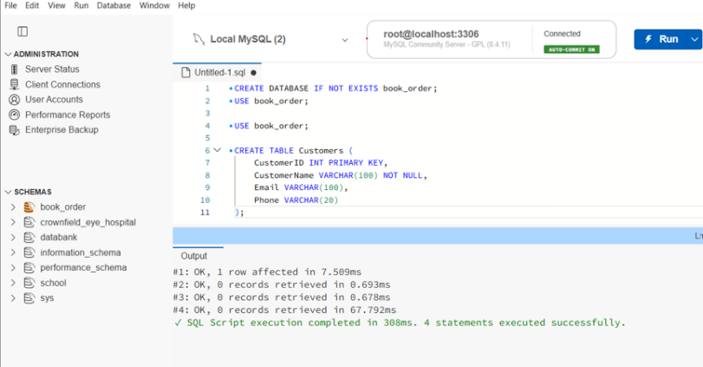

Books table created
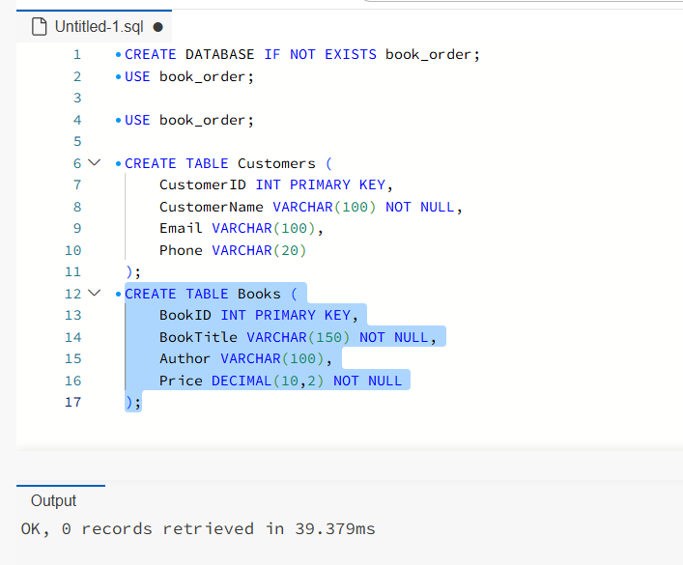

Orders table created
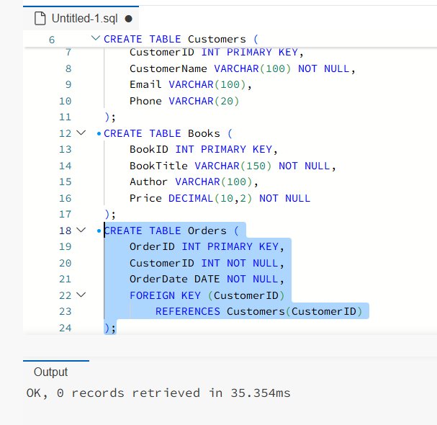

OrderDetails table created
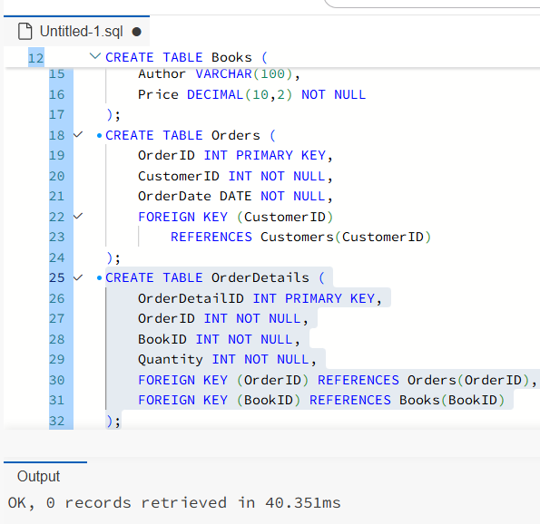

GROUP MEMBER 2 — DATA INSERTION

1. SQL INSERT statements (sample data)
INSERT INTO Customers (CustomerID, CustomerName, Email, Phone) VALUES
(1,'John Smith','john@gmail.com','07123456789'),
(2,'Mary Jones','mary@gmail.com','07234567890'),
(3,'David Brown','david@gmail.com','07345678901'),
(4,'Sarah Wilson','sarah@gmail.com','07456789012'),
(5,'James Taylor','james@gmail.com','07567890123');
INSERT INTO Books (BookID, BookTitle, Author, Price) VALUES
(1,'Database Systems','Thomas Connolly',45.00),
(2,'Learning SQL','Alan Beaulieu',30.00),
(3,'Python Programming','John Zelle',40.00),
(4,'Web Development','Jon Duckett',35.00),
(5,'Data Science Basics','Joel Grus',50.00);
INSERT INTO Orders (OrderID, CustomerID, OrderDate) VALUES
(1,1,'2026-10-01'),(2,2,'2026-10-02'),
(3,3,'2026-10-03'),(4,4,'2026-10-04'),(5,5,'2026-10-05');
INSERT INTO OrderDetails (OrderDetailID, OrderID, BookID, Quantity) VALUES
(1,1,1,2),(2,2,2,1),(3,3,3,3),(4,4,4,2),(5,5,5,1);

2. Five records on each table
Five sample records were inserted into Customers, Books, Orders and OrderDetails. The screenshots below show successful inserts and verification of the final table.

3. Screenshots of inserted records

Customers: five rows affected
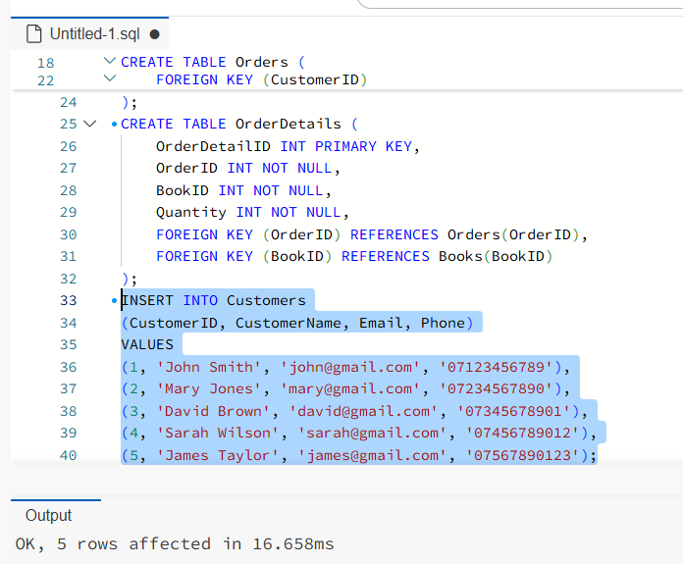

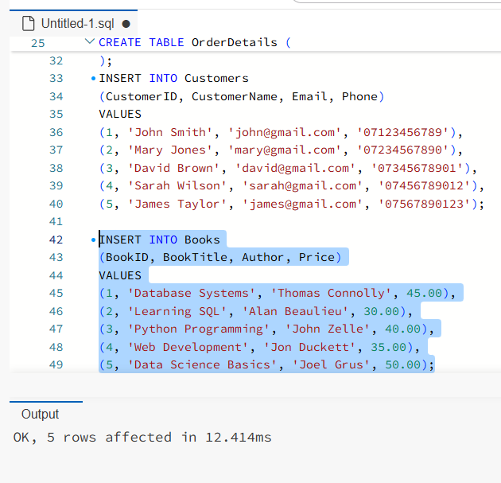
Books: five rows affected

Orders: five rows affected
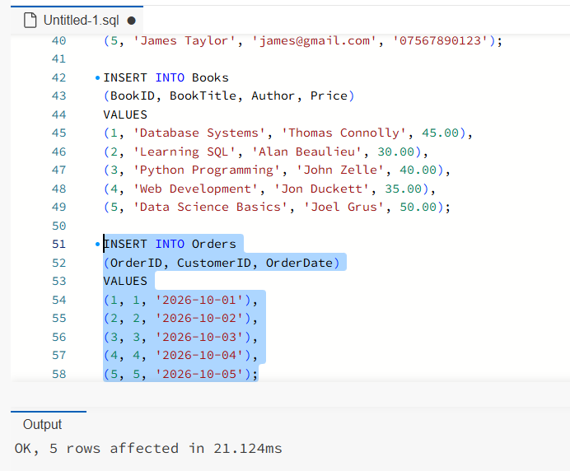

OrderDetails: five records displayed
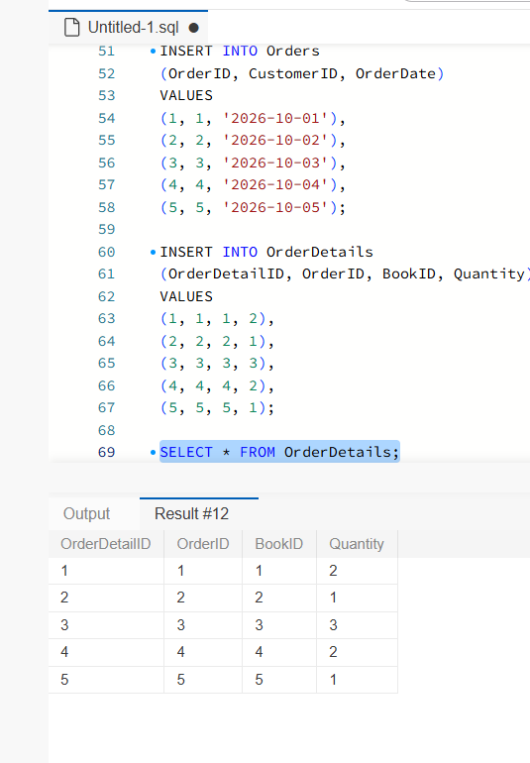

GROUP MEMBER 3 — SQL QUERIES AND RESULTS

Query 1 — Retrieve all records (SELECT)

SELECT * FROM Customers;
This query retrieves all rows and columns from the Customers table. The asterisk selects every column, including customer ID, name, email address and phone number. The results display the five sample customer records stored in the database. It is useful for checking that the customer data was inserted correctly and for viewing the complete information available for each customer.
Query 1: Customers’ query and results
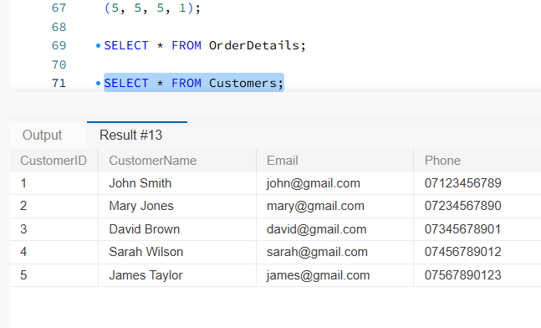

2. Query 2 — Filter data (WHERE)

SELECT * FROM Books
WHERE Price > 35;
This query retrieves books with a price greater than 35. The WHERE clause applies a condition to the Books table, so only matching rows appear. The output includes Database Systems, Python Programming and Data Science Basics. Books priced at 35 or below are excluded. This shows how a condition can narrow the results and help users find records meeting a particular requirement.

Query 2: Books priced above 35
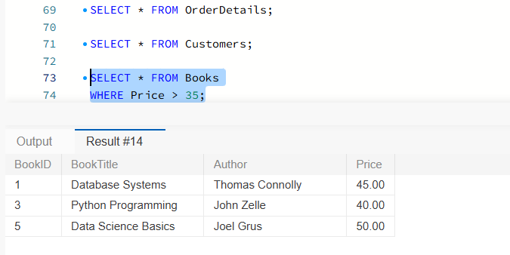

3. Query 3 — Join two tables (INNER JOIN)
SELECT Customers.CustomerName, Orders.OrderID, Orders.OrderDate
FROM Customers
INNER JOIN Orders ON Customers.CustomerID = Orders.CustomerID;
This INNER JOIN combines the Customers and Orders tables using the matching CustomerID values. CustomerID is the primary key in Customers and a foreign key in Orders. The query displays each customer name alongside the corresponding order ID and order date. Five matching orders appear in the results. It demonstrates how related information from different tables can be retrieved together without duplicating customer details in the Orders table.

Query 3: Customer names, order IDs and dates

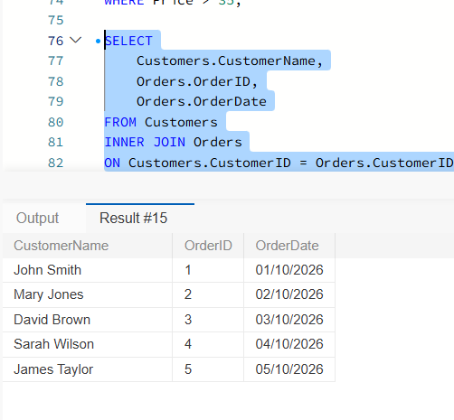
INDIVIDUAL COLLABORATION REPORT
The assessment was planned for a group of three. I created the Book Order database, entered sample records, ran three SQL queries and captured screenshots of the results. I prepared the document for sharing with the other members so they could review the work. The Workshop 2 dataset was unavailable, so I used a sample design. I will update this report to describe any contributions made by other members after they respond. This report reflects my own work and does not claim that others completed unconfirmed tasks.

